# AWS Setup

Below is a detailed guide of how-to setup AWS. So far this covers the creation of AWS account and the creation of the Windows Server 2019 Instance intended to be used for AD.

Contents

AWS Setup 1

Creating Email Account: 2

AWS Finance 2

Windows Server 4

## Creating Email Account:

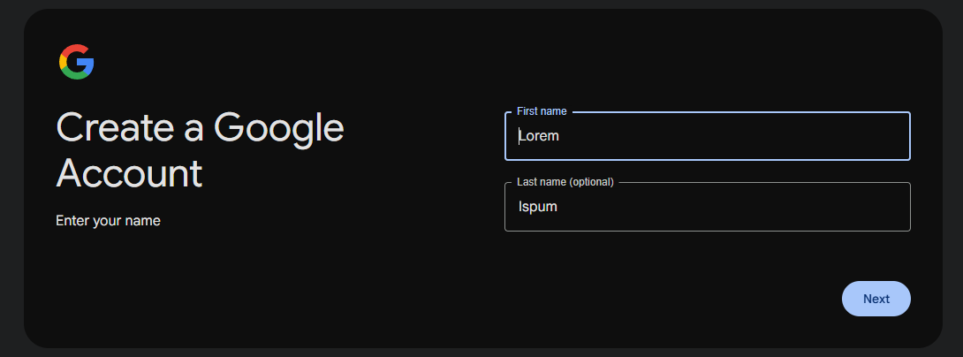

LoremIspum Account name

loremispum352@gmail.com

LoremIspumStrongestWhale

LoremIspumStrongestWh@le32 is 4 Root User

## AWS Finance

AWS accounts created. Open and turn on Billing and Cost management data for reimbursement.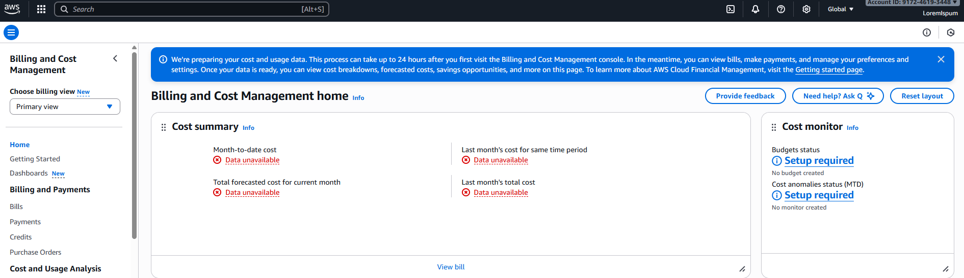

Following this a 200-dollar budget was set for the year:

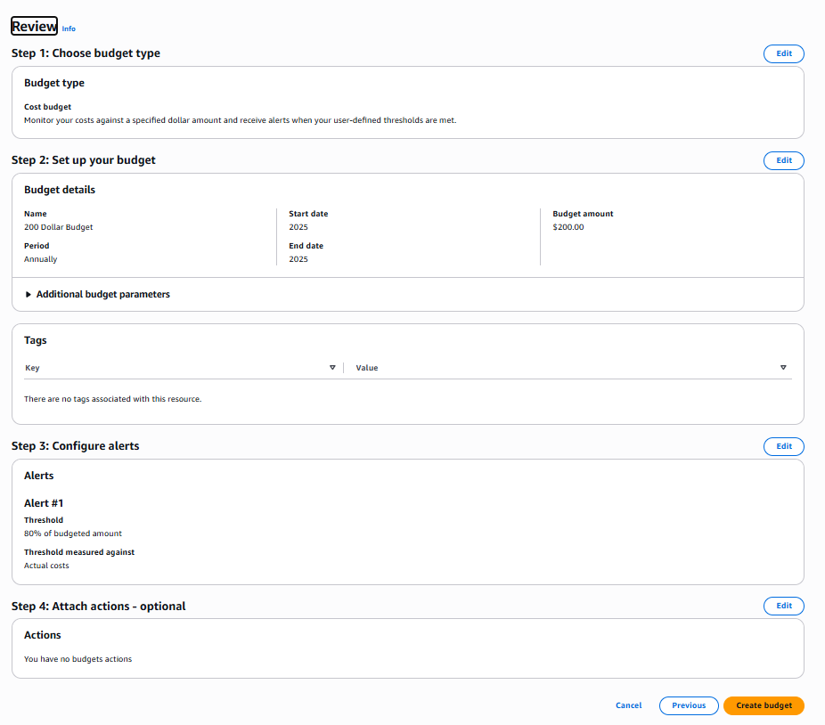

Additionally two alerts where set, one for 50% use and the other 80% to notify if the budget is creeping:

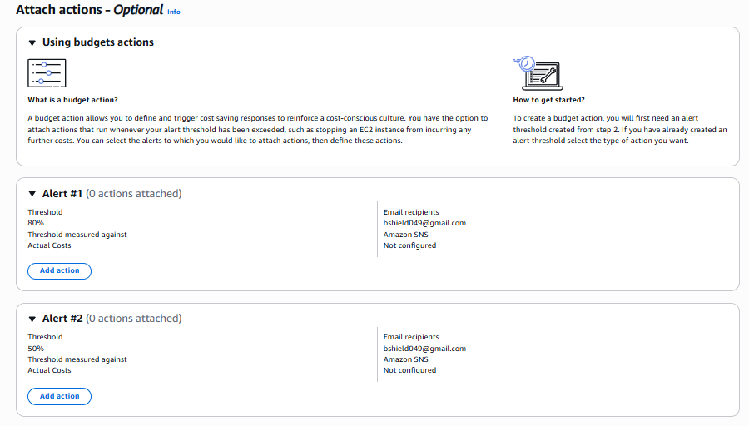

Now for AD, there is a preexisting AD located on a local Virtual box, but due to internet speeds a new instance of windows 10 server on the cloud has been set up the same as the local version that’s located on virtual box.

## Windows Server

First Log into AWS and type in EC2 in the search bar, click on it and then from there look at the bar on the left-hand side of the screen. There should be a field called Instances, select that field and press launch instance like so:

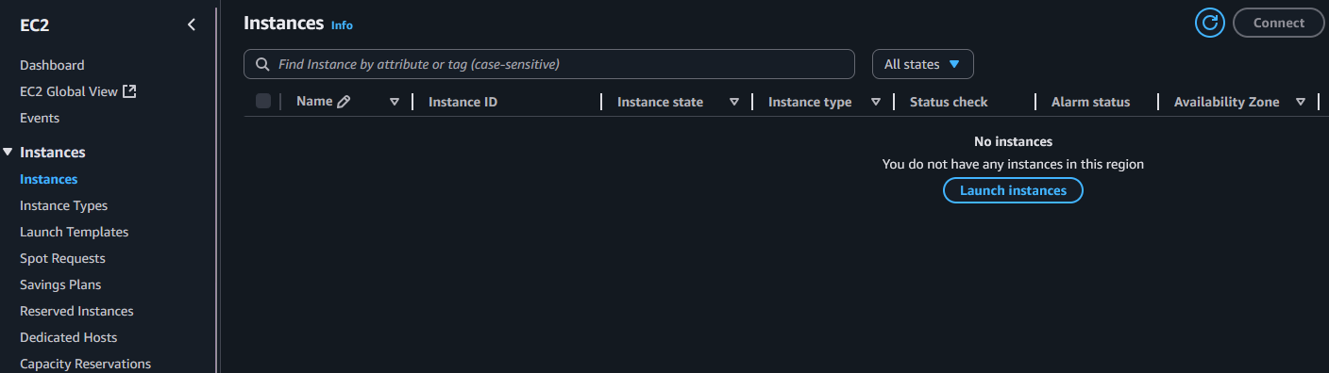

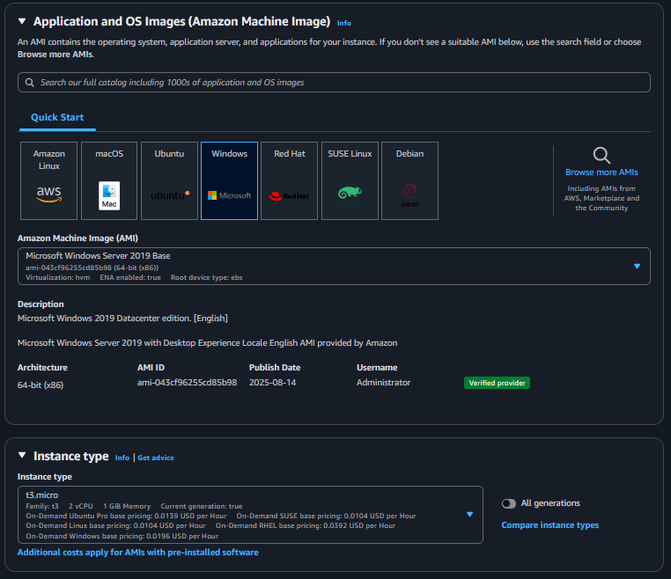

Windows Server 2019 with an instance type of t3.micro (small cheap vm for testing in real scenario we would use a production instance)

Before launching the instance create a Key pair to connect to VM securely:

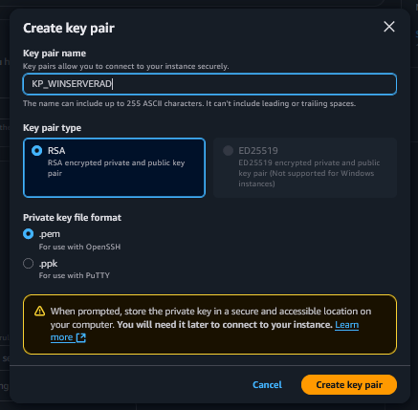

Key Pair Windows Server AD:

It saves it as a Pem file which can be used to open with OpenSSH, alternatively putty can be used with a .ppk



Okay the Windows 2019 Server has been successfully created. From here it was configured to work like the local AD that was created. Now time to connect with the key pair as previously discussed.

From the instances page navigate to the rdp client page. Download the remote desktop profile click on it to open it. While doing this also click get password:

Once clicked “get password” it will take you here, upload the .pem to get the password.

Okay, thanks to remote desktop protocol the virtual machine can now be accessed.

VM has been temporarily stopped to save finances. Though it can be resumed at any time. It will still cost a small amount of money while it is paused, but much less.